**Experiment Title-2.4**

**Student Name: ADITYA RAJ** **UID:21BCS8948**

**Branch: CSE**  **Section/Group: ONBCS703/A**

**Semester: 3rd**

**Subject Name: DBMS Subject Code:21 CSH-214**

**1. Aim/Overview of the practical: Write a query to create a view that finds the salesman who has the customer with the highest order at least 3 times on a day.**

**Relation1: Customer**

customer_id | cust_name | city | grade | salesman_id

-------------+----------------+------------+-------+-------------

3002 | Nick Rimando | New York | 100 | 5001

3007 | Brad Davis | New York | 200 | 5001

3005 | Graham Zusi | California | 200 | 5002

3008 | Julian Green | London | 300 | 5002

3004 | Fabian Johnson | Paris | 300 | 5006

3009 | Geoff Cameron | Berlin | 100 | 5003

3003 | Jozy Altidor | Moscow | 200 | 5007

3001 | Brad Guzan | London | | 5005

**Relation2: elitsalesman**

salesman_id | name | city | commission

-------------+------------+----------+------------

5001 | James Hoog | New York | 0.15

5002 | Nail Knite | Paris | 0.13

5005 | Pit Alex | London | 0.11

5006 | Mc Lyon | Paris | 0.14

5007 | Paul Adam | Rome | 0.13

5003 | Lauson Hen | San Jose | 0.12

**CODE :-**

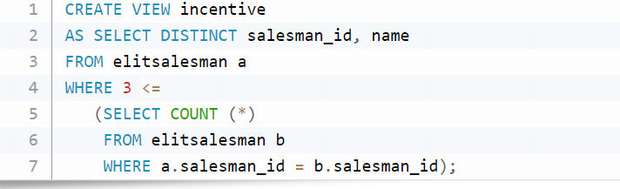

output:

